**CHANDIGARH UNIVERSITY**

**UNIVERSITY INSTITUTE OF ENGINEERING**

**DEPARTMENT OF COMPUTER SCIENCE AND ENGINEERING**



|  |  |
| --- | --- |
| **Submitted by:**  **Yash Gupta 20BCS5009** | **Submitted To:**  Ajay Kumar (E13141) |
| **Subject Name:** | Machine Learning Lab |
| **Subject Code:** | 20CSP-317 |
| **Branch:** | CSE |
| **Semester:** | 5th |

LAB INDEX

**Experiment 2.1**

1. **Aim/Overview of the practical:**

**SVM**

1. **Source Code:**

import pandas as pd

from sklearn.datasets import load_iris

from ast import Lambda

from sklearn.model_selection import train_test_split

from sklearn.svm import SVC # Support Vector Classifier

import matplotlib.pyplot as plt

%matplotlib inline

# 1

iris = load_iris()

dir(iris)

iris.feature_names

iris.target_names

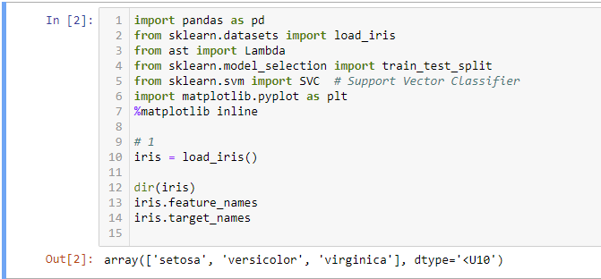

iris.data

iris.target_names

len(iris.data)



df = pd.DataFrame(iris.data, columns=iris.feature_names)

df

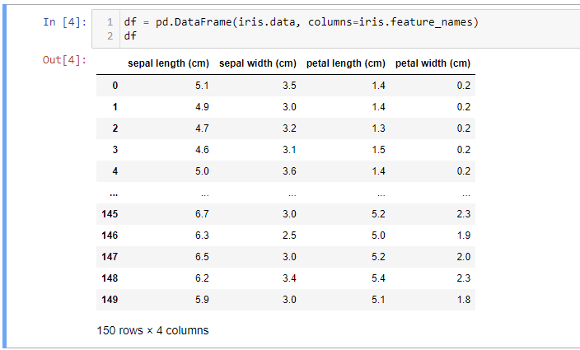

df["target"] = iris.target

df[40:60]

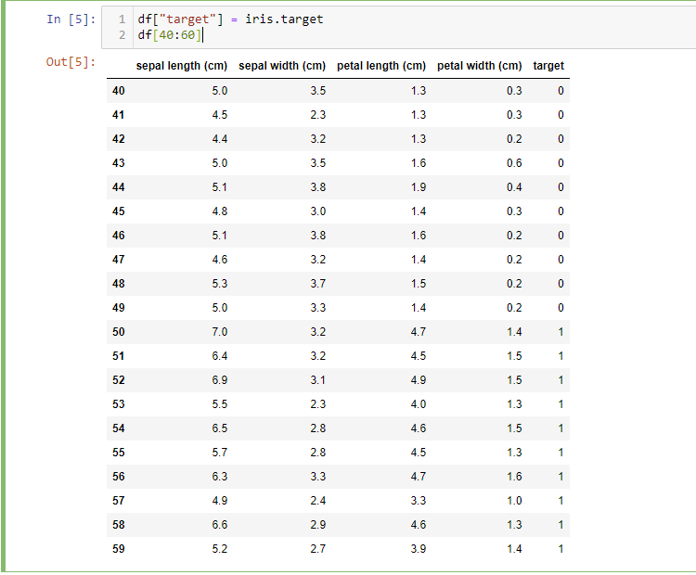

df.head()

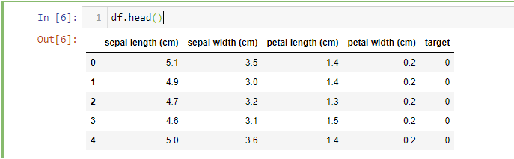

df["flower_name"] = df.target.apply(lambda x:iris.target_names[x]) #lambda to change row/column

df

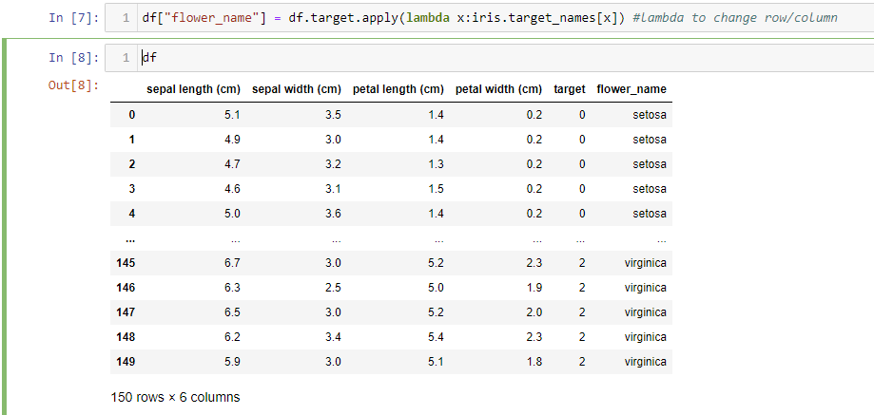

df.head()

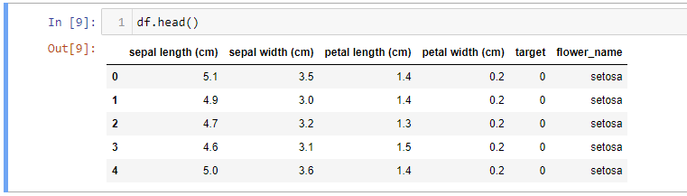

df[45:55]

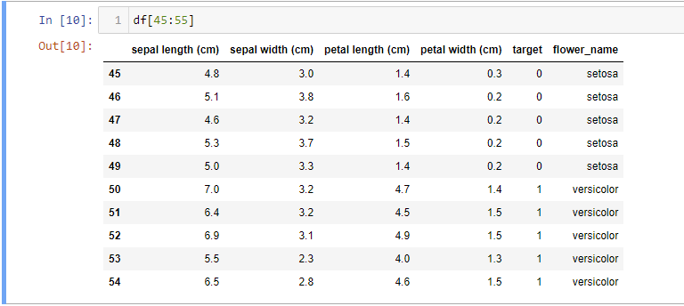

df0=df[:50]

df1=df[50:100]

df2=df[100:]

plt.xlabel("sepal length")

plt.ylabel("sepal breadth")

plt.scatter(df0["sepal length (cm)"],df0["sepal width (cm)"],color="blue",marker="o")

plt.scatter(df1["sepal length (cm)"],df1["sepal width (cm)"],color="green",marker="*")

plt.scatter(df2["sepal length (cm)"],df2["sepal width (cm)"],color="yellow",marker="+")

x=df.drop(["target","flower_name"],axis="columns")

y=df.target

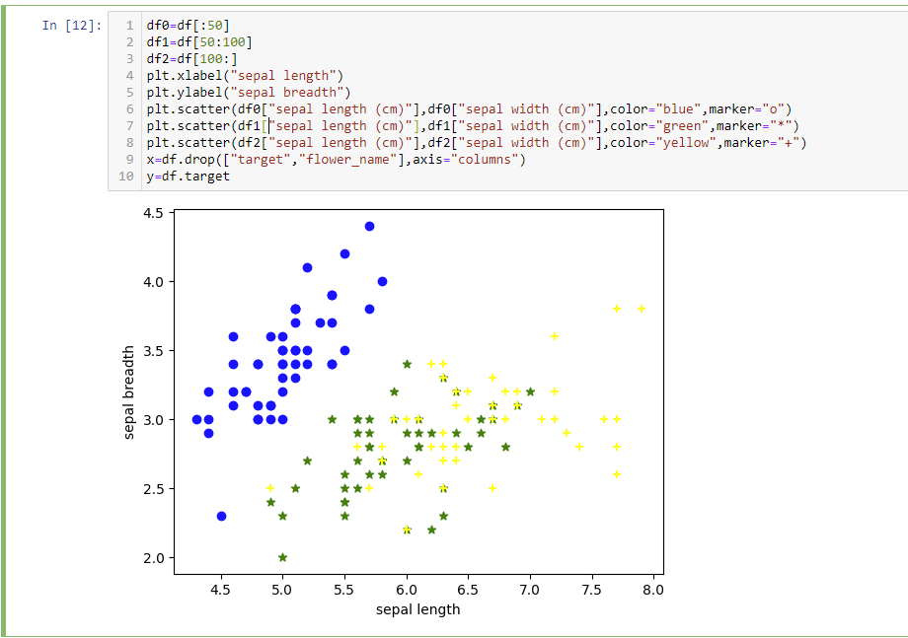

df0=df[:50]

df1=df[50:100]

df2=df[100:]

plt.xlabel("sepal length")

plt.ylabel("sepal breadth")

plt.scatter(df0["sepal length (cm)"],df0["sepal width (cm)"],color="blue",marker="o")

plt.scatter(df1["sepal length (cm)"],df1["sepal width (cm)"],color="green",marker="*")

plt.scatter(df2["sepal length (cm)"],df2["sepal width (cm)"],color="yellow",marker="+")

x=df.drop(["target","flower_name"],axis="columns")

y=df.target

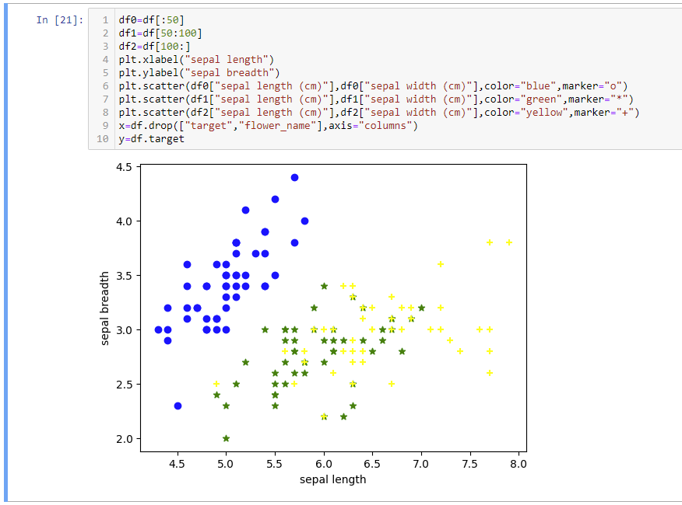

x = df.drop(["target", "flower_name"], axis = "columns")

y = df.target

print(y)

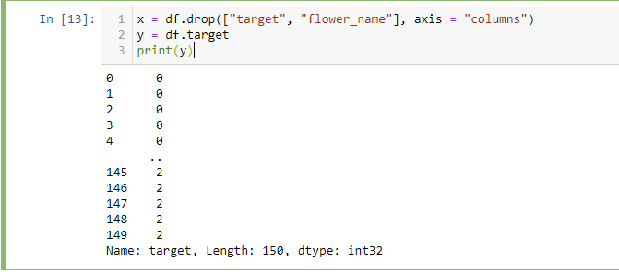

x_train, x_test, y_train, y_test = train_test_split(x,y,test_size=0.2)

len(y_test)

x_train,x_test,y_train,y_test=train_test_split(x,y,test_size=0.2)

len(y_test)

model=SVC()

model=SVC(C=1.0, kernel='linear', degree=3, gamma=10, coef0=0.0, shrinking=True, probability=False, tol=0.001, cache_size=200, class_weight=None, verbose=False, max_iter=-1, decision_function_shape='ovr', break_ties=False, random_state=None)

model.fit(x_train,y_train)

model.score(x_test,y_test)

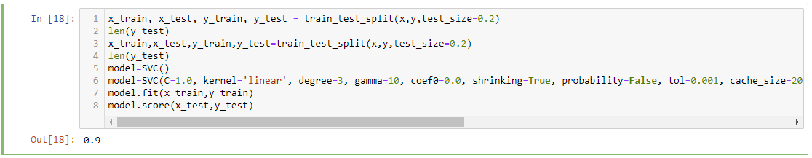

**Evaluation Grid :**

|  |  |  |  |
| --- | --- | --- | --- |
| **Sr. No.** | **Parameters** | **Marks Obtained** | **Maximum Marks** |
| **1.** | **Student Performance  (Conduct of experiment) objectives/Outcomes.** |  | **12** |
| **2.** | **Viva Voce** |  | **10** |
| **3.** | **Submission of Work Sheet (Record)** |  | **8** |
|  | **Total** |  | **30** |